Women’s Rights, Warlords, and
the US Occupation of Afghanistan

Malalai Joya Speaks Out

She is one of the most popular members of the new Afghan parliament.

She has been called “the most famous woman in Afghanistan.”

She has survived numerous assassination attempts for speaking out against criminal warlords.

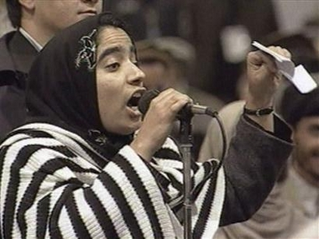

Saturday, March 18
5:00 pm

Faulkner Gallery
Santa Barbara Central Library
40 East Anapamu Street

FREE! Everyone Welcome.

Afghan handicrafts will be on sale.

Sponsored by RAWA Santa Barbara,
supporting the Revolutionary Association of the Women of Afghanistan.
Co-sponsored by the Santa Barbara Women’s Political Committee
and the UCSB Women’s Center

Call 805-569-2331 Email Sbrawa@aol.com Visit www.rawasb.org

