Women’s Rights, Warlords, and
the US Occupation of Afghanistan

Malalai Joya Speaks Out

She is one of the most popular members of the new Afghan parliament.

She has been called “the most famous woman in Afghanistan.”

She has survived numerous assassination attempts for speaking out against US-backed warlords.

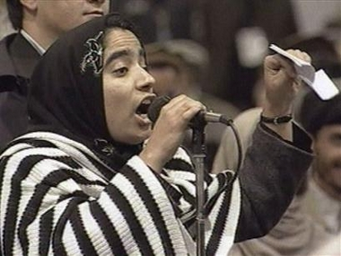

Join us for an International Women’s Day celebration with Malalai Joya

There will also be a screening of excerpts from
“View From a Grain of Sand,” a new documentary about Afghan women, with film maker Meena Nanji

Emcee: Sonali Kolhatkar (KPFK, Afghan Women’s Mission)

WHEN: March 6, 2006, 7 pm

WHERE: Immanuel Presbyterian Church,
Westminister Chapel
663 S. Berendo, Los Angeles
(near the corner of Wilshire and Vermont)

Sponsored by Code Pink for Peace, AWARE, Global Voices for Justice, Casa del Pueblo, Sweatshop Watch.
For more information, call 626-676-7884, or
visit www.afghanwomensmission.org for a complete listing of events.
Now 27-year old Malalai Joya visits the US
for the first time since her 2005 election.

"They will kill me but they will not kill my voice because it will be the voice of all Afghan women. You can cut the flower, but you cannot stop the coming of spring." – Malalai Joya, BBC News, January 2006

